Try as guest Scenario

1-Follow tutorial: buy 8000$ bitcoin then go to my portfolio.
Trading Section
a)Press trade now
b) press join contest (found something need to improve “Second point in improvement”)
c) Buy Etherum.

Reward Section
a)Discover redeem reward. Redeem from cryptokities with a not enough amount of money.
b)Find bounties

Complete Profile Scenario
1)https://altcoinfantasy.com/guest/complete

Profile Section

Improvements:
1- offer some pdf file, articles and video tutorial for real cryptocurrency trading. Anyone use your app his main goal is to learn how to trade even if he is here for fun. So any resources you offers will be really appreciated.
2-Loading data table is just a text file. It will be better to offer any motion.(https://altcoinfantasy.com/user_contests/378329)
3)Singup I can’t use chrome password manager to suggest a password for me.
4) skill level drop down menu. I can’t see the font without the hover.

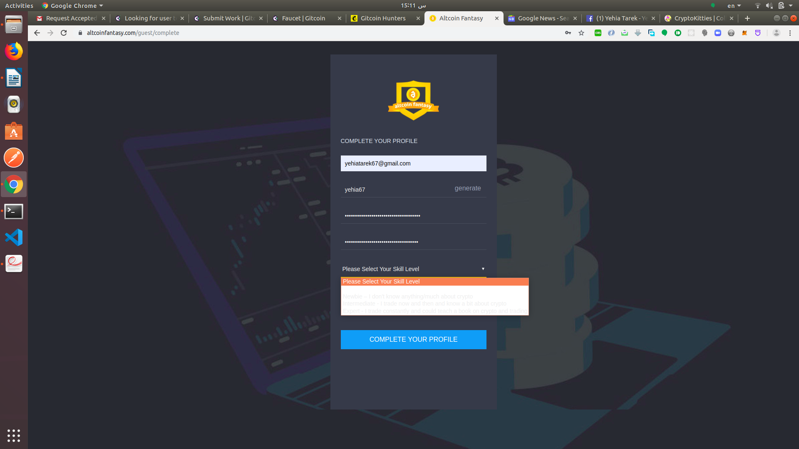

https://altcoinfantasy.com/guest/complete
5) Crowdholding is the best blockchain platform for user testing you could try it

